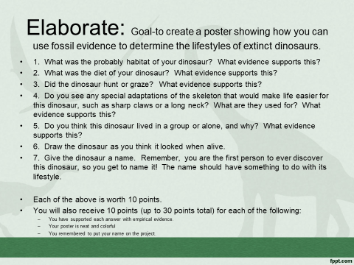
Rubric:
5-Excellent 4-Good 3-Needs Improvement 2-Attempted 1-Not There
__You have given the habitat of the dinosaur.
__ You have identified the diet of the dinosaur.
__ You have identified whether the dinosaur hunts or grazes..
__ You have identified adaptations of the skeleton and their uses.
__ You have identified the dinosaur’s herd situation.
__ You have drawn what the dinosaur must have looked like when alive.
__ You have named the dinosaur appropriately.
__ You have supported 1-5 with evidence.
__ Your work is neat and colorful.
__ You put your name on the project.
___ x2= ____/100

