Article Title: “Why Sloth Evolution Is So Sloth-Like”

Scientists still don't know why sloths aren't evolving.TWEET
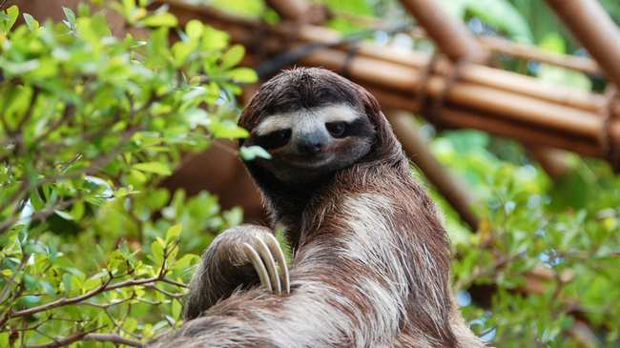
Three-toed sloth. Image: Flickr/SergioDelgado
Everyone knows that sloths are really, really, really slow.
On average, these tree-dwelling mammals creep at a pace of just six to eight feet per minute. In a single day, they'll travel 120 feet at most. More than half of their life is spent sleeping, and even during waking hours, most sloths just hang there, motionless. Sloths are so slow, they earned their very own noun to describe, well, their slothfulness.
But despite their well-known idiosyncrasies, scientists aren't sure why sloths haven't evolved to better exploit their unusual ecological niche. Over time, many animals develop novel traits that make them more successful and efficient as a species, especially in new environments. This process is called adaptive radiation, and is best illustrated by the rapid diversification of Darwin's finches in the Galápagos Islands.
In an evolutionary context, however, today's sloths appear happy to stay put in trees, feeding on leaves, and expending as little energy as possible to compensate.
"Among vertebrates, this is the rarest of lifestyles," said Jonathan Pauli, a professor of forest and wildlife ecology at the University of Wisconsin-Madison. "When you picture animals that live off plant leaves, they are almost all big—things like moose, elk and deer. What's super interesting about arboreal folivores is that they can't be big."
In a new study published this week in American Naturalist, Pauli and several other biologists set out to answer the enduring question: What's stopping modern sloths from diversifying?
Very few vertebrates live solely among the treetops. And of arboreal folivores, such as koalas, and some lemurs and monkeys, sloths are the slowest and most metabolically lethargic. According to the study's findings, three-toed sloths possess the slowest digestion rate of any mammal. In order to conserve precious energy, these sloths will burn a mere 110 calories per day, or the equivalent of a baked potato.
"Most of the world is forested, but the energetic constraints of a leafy diet seem to prevent adaptive radiation," Pauli added. "Think about it. The food sucks. It's only plant leaves. You have to exploit a very constrained niche."

Juvenile two-toed sloth. Image: Flickr/Jerry Kirkhart
The team of researchers theorized that sloth evolution has been significantly hampered by the animals' nutritionally poor diet. Some leaf eaters, like giant pandas, are forced to consume up to 80 pounds of foliage every day in order to meet their caloric needs. But since sloths have relatively tiny digestive tracts, they've developed a unique set of adaptations that allow them to survive on such meager provisions.
"The measurement was intended to find out what it cost the sloth to live over a day," said Pauli, who explained that sloths will regulate their body temperature and limit their activity to make up for their folivorous lifestyle. To test their hypothesis, the study's authors measured the energy expenditure of two and three-toed sloths using isotopically labeled water that allowed them to calculate their metabolic rates over long periods of time.
What the team discovered was that sloths are so tightly constrained by their nutritional needs, that adaptation would actually be disadvantageous. Basically, sloths can't specialize to fit their niche anymore than they already have.
But despite their seemingly conservative lineage, sloths are actually incredibly remarkable when it comes to evolution. One study found that ancient sloth ancestors gained up to 200 pounds every million years, which is some of the fastest size growth ever recorded. At at one point in time, according to fossil records, more than 50 sloth species existed in eight different families. The Giant Sloths of the Pleistocene Epoch went extinct around 10,000 years ago. The three toed sloth is a relative of the Giant one, weighing about 180 pounds less. During the Pleistocene, it was advantageous for the sloth to be large, as most mammals were at the time, and this made for easier competition. The modern sloth’s small size allows them to easily climb in trees, eat less to survive, and move slower.

