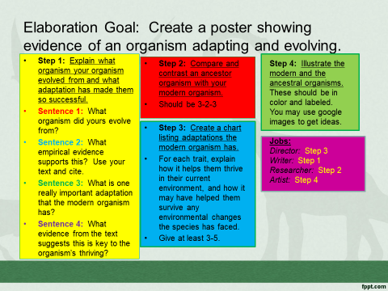
4-Excellent 3-Good 2-Needs Improvement 1-Not Present
__ Paragraph explains how the modern organism evolved and adapted from the extinct in four sentences.
__ Venn diagram compares and contrasts the modern organism and its ancestor in 3-2-3 format.
__ Chart gives at least three adaptations and explains how they help the modern organism survive.
__ Both the modern and the extinct organisms are illustrated neatly and in color.
__ All information is correct and evidence is present from the source given.

