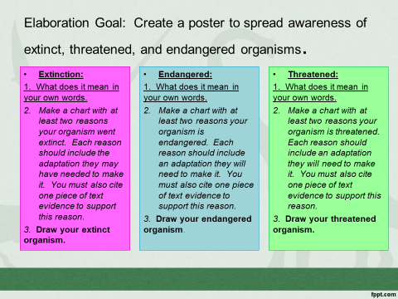
4-Excellent 3-Good 2-Needs Improvement 1-Not Present
__ Extinction, Threatened, and Endangered are explained in your own words.
__ There is a chart for each with at least two reasons the organism goes in this category.
__ Each reason in each chart has an adaptation that may have helped/would help the organism not go extinct.
__ Text evidence is cited for each chart.
__ There is a picture of each organism illustrated to the best of the group’s ability.

