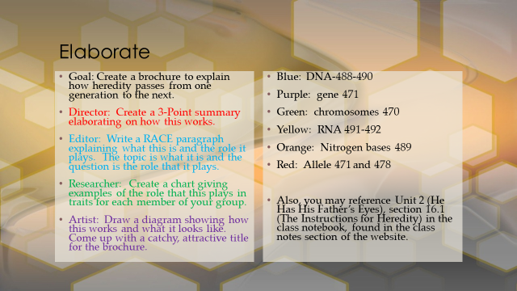

4-Excellent 3-Good
2-Needs Improvement 1-Not There
___ Topic is explained accurately in a RACE paragraph.
___ An accurate 3-point summary is given for how it works.
___ Examples of traits in chart are accurate and the role of the topic is explained.
___ There is a title and a diagramed illustration of the topic.
___ All instructions are followed and the group used time wisely.
Score _____x5= _______/_____

