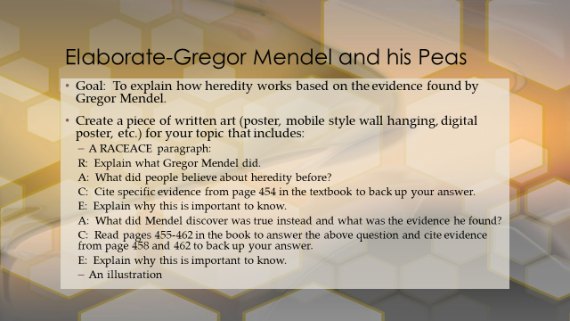

4-Exceeds Expectation 3-Meets Expectation 2-Approaching Expectation 1-Not Approaching
___ The previous popular belief on how traits were inherited is explained.
___ The explanation is supported with text evidence and the importance is illustrated.
___ The evidence that changed this idea is identified.
___ This evidence is explained with text evidence and the importance of it is illustrated.
___ Proper citation is used for all text evidence.

