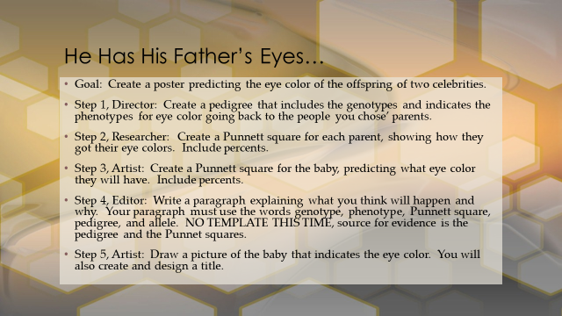

4-Excellent 3-Good 2-Needs Improvement 1-Not Present
___ Pedigree is complete and accurate.
___ Parent and baby Punnett Squares (3) are complete and accurate.
___ Illustration represents the trait predicted.
___ Paragraph explains the prediction based on the evidence in the pedigree and Punnett squares.
___ Paragraph is accurate and contains all of the required terms.

