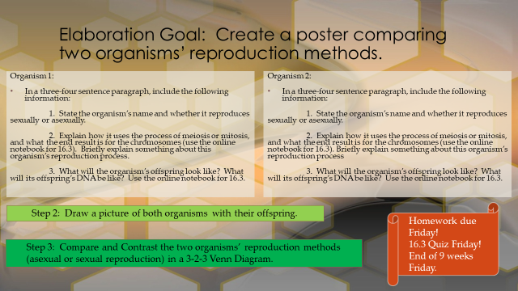

4-Excellent 3-Good 2-Needs Improvement 1-Not There
__ Reproduction method is accurately identified for each organism and briefly explained.
__ The process of meiosis or mitosis is accurately identified for each organism, with the correct end result.
__ The organism’s appearance based on DNA is accurately explained for each organism.
__ There are pictures of both organisms and their young, accurately portrayed, based on their type of reproduction.
__ The Venn diagram accurately compares and contrasts the two organisms’ reproductive methods in 3-2-3 format.
Total: ____ x5= _____/_____

