Corn
Corn can reproduce sexually. “For those of you serious about semantics, let's review two definitions relevant to sex in the corn field. Pollination is the act of transferring the pollen grains to the silks by wind or insects. Fertilization is the union of the male gametes from the pollen with the female gametes from the ovary. Technically, pollination usually occurs successfully (i.e., the pollen reaches the silks), but unsuccessful fertilization results in poor kernel set on the ears. Pollen grain germination occurs within minutes after a pollen grain lands on a receptive silk. A pollen tube, containing the male genetic material, develops and grows inside the silk, and fertilizes the ovary within 24 hours. Pollen grains can land and germinate anywhere along the length of an exposed silk. Pollen grain germination occurs within minutes after a pollen grain lands on a receptive silk. A pollen tube, containing the male genetic material, develops and grows inside the silk, and fertilizes the ovary within 24 hours. Pollen grains can land and germinate anywhere along the length of an exposed silk,” according to agry.perdue.edu. The cells use the process of meiosis to reproduce.
For more information about sexual reproduction and the process of meiosis, see the 7th Grade Master Notebook, Unit 2, section 16.3.
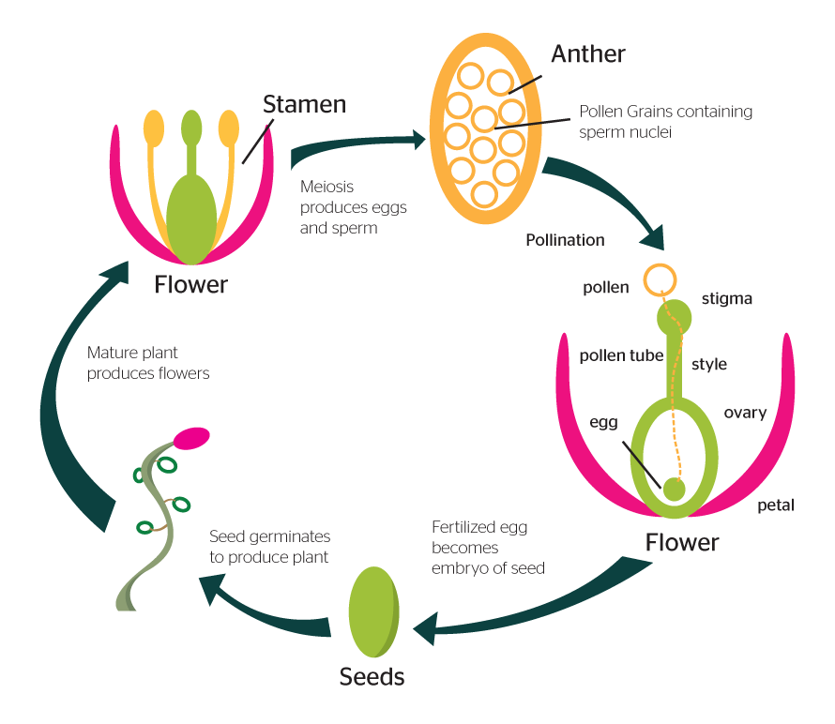
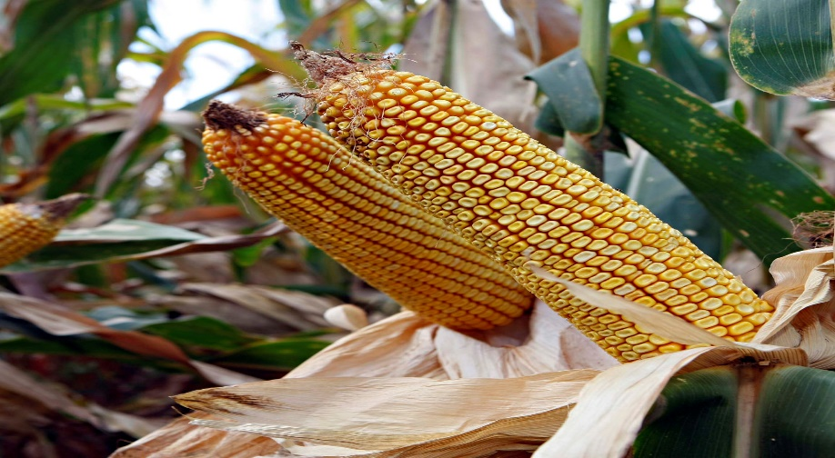
Bears
Bears reproduce sexually. “Bears usually reach sexual maturity between the ages of 3 and 5. A female bear gives birth to one to four cubs every 2 to 4 years. Male and female bears live in their own territories and do not really come into contact with each other outside of the mating season. The mating season begins in May and lasts until July and during this time the males may have fierce battles over the same female. The bear has delayed implantation, which means that even though the bear mates in June–July, the fertilized egg will only attach to the uterus in late autumn and the bear fetus will begin to develop. The bear's gestation period is 194–278 days. The cubs are born into the winter den in January–February. There are usually one or two cubs, sometimes three, but litters with four cubs are also not unheard of. A bear cub feeds on its mother's fatty milk during the first few months of its life. The cubs will usually follow their mother until the May–June of the following year, but in some cases a mother bear might be accompanied by cubs from two separate litters,” according to largecarnivores.fi. Bears require sperm and egg for fertilization, give live birth, and use meiosis to reproduce cells.
For more information about sexual reproduction and the process of meiosis, see the 7th Grade Master Notebook, Unit 2, section 16.3.
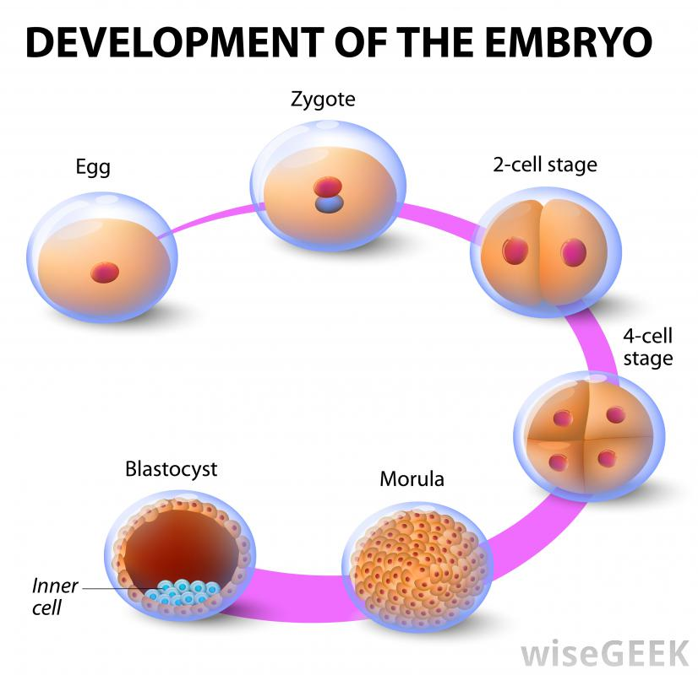

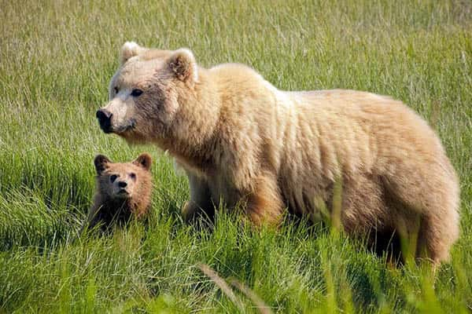
Sea Turtle
Sea Turtles reproduce sexually. “For most species, courtship activity usually occurs several weeks before the nesting season. Two or more males may court a single female. Males have enlarged claws on their front flippers. These aid males in grasping the shells of the females during mating. Fertilization is internal. Copulation (mating) takes place in the water, just offshore. Like other turtles, sea turtles lay eggs. Females come ashore on a sandy beach to nest a few weeks after mating. A female sea turtle crawls above the high tide line and, using her front flippers, digs out a “body pit.” Then using her hind flippers, she digs an egg cavity. The depth of the cavity is determined by the length of the stretched hind flipper and can be up to 1 m (3.3 ft.) deep. A female deposits 50 to 200 (depending on the species) Ping Pong ball shaped-eggs into the egg cavity. The eggs are soft-shelled, and are papery to leathery in texture. They do not break when they fall into the egg cavity. The eggs are surrounded by a thick, clear mucus,” according to seaworld.org. They bury their on shore nest for eggs to gestate. Cells reproduce using meiosis.
For more information about sexual reproduction and the process of meiosis, see the 7th Grade Master Notebook, Unit 2, section 16.3.
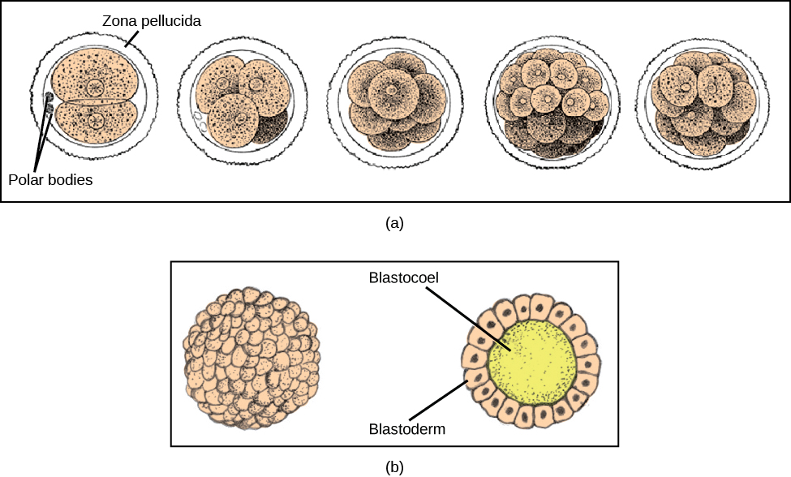
Owls
Owls reproduce sexually. “Variations in breeding schedule may correspond to the weather, food availability, competition from other owls, disease, and availability of a suitable mate. Courtship rituals vary from species to species, but invariably involve calling. The male will usually try and attract a female to a suitable nest site and may use special courtship flights, calls and offerings of food. Copulation often follows the acceptance of food by the female. There is often mutual preening, with the pair perched close together. As a general rule Owls are monogamous - pairs are comprised of one male and one female, neither one of which has any involvement with other nesting birds. Owls lay between one and thirteen eggs, depending on the species and also on the particular season; for most, however, three or four is the more common number. The eggs are rounded and white; there is little need for cryptic markings given the concealed nature of most nest sites, and the vigour with which they are defended. Incubation of the eggs usually begins when the first one is laid, and lasts, in most species, for around thirty days. During incubation, the eggs are rarely left alone. Female owls, like many other birds, develop a sparsely feathered area on their bellies called a brood patch. The almost bare skin has a higher density of blood vessels than other parts of the skin, providing a direct source of warmth when in contact with the eggs,” according to owlpages.com. When fertilization occurs, the process of meiosis reproduces cells.
For more information about sexual reproduction and the process of meiosis, see the 7th Grade Master Notebook, Unit 2, section 16.3.
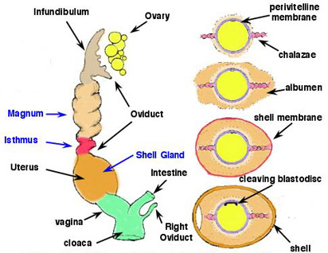
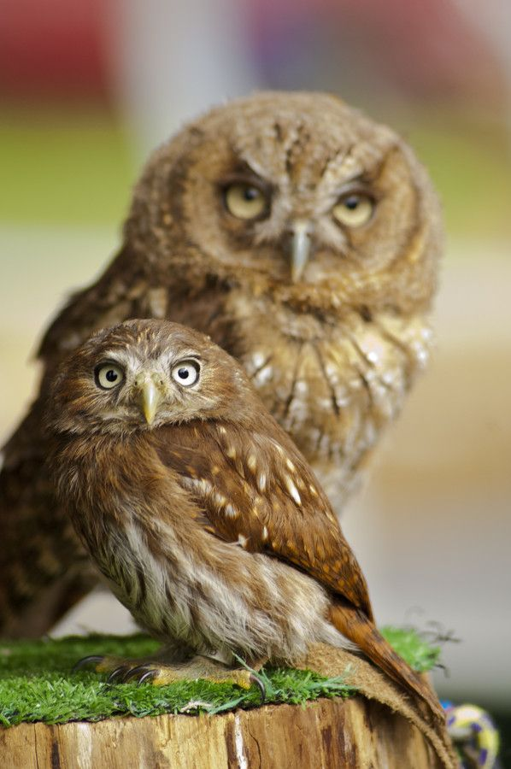
Roses
Roses usually reproduce asexually, but they can produce sexually. They do this naturally by their pollen being carried by insects, wind, or other weather. “Sexual propagation of roses can be slow and not entirely successful. Hybrid tea roses have difficulty producing rose hips and seeds, while old garden and shrub varieties are able to produce them more easily. Rose flowers have both male and female parts. Anthers bearing pollen are on the outside. The stigma and underlying ovaries, covered by petals, are in the center. In controlled pollination, pollen from mature anthers may be transferred by hand to a selected flower when pistils appear sticky...Pollination has occurred when the base of the flower, known as the hip, begins to swell. Rose seeds take approximately four months to form,” according to homeguides.sfgate.com. Once the pollination occurs, the process of meiosis begins to reproduce cells.
For more information about sexual reproduction and the process of meiosis, see the 7th Grade Master Notebook, Unit 2, section 16.3.
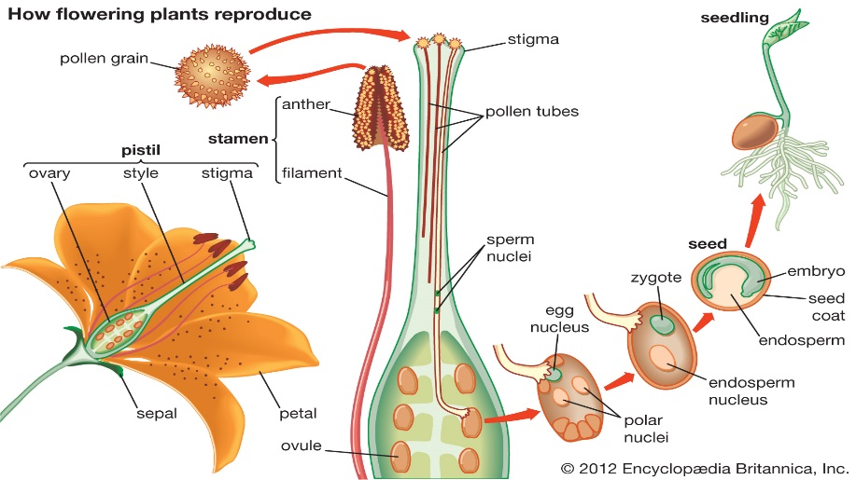

Sharks
Sharks usually reproduce sexually. “With sexual reproduction there is the mating of a male and female shark that takes place. The male is able to deposit sperm into the female which will fertilize the eggs. There have been very few occurrences of such mating being observed by humans due to the aggressive nature of the males during mating. The males may become aggressive towards each other in order to have the right to mate with females. The males will circle around the females and even bite her skin in order to get her attention. Many older females have been seen with substantial bite marks on them from the mating rituals. Experts believe the skin of the females is thicker though than males and the bites aren’t painful… Some species of sharks give live birth to their young. This is referred to as viviparity and includes Hammerhead Sharks. Others deposit eggs into the water such as the Port Jackson Shark. This is called oviparity. The majority of species of sharks though are ovoviviparity where the eggs hatch inside of the mother. The young are then born alive and they are able to completely function on their own when they are born. This process is one that allows the young to be born at a larger size, and that can help them to ultimately have a higher chance of surviving to adulthood. The females will often migrate to sheltered areas including bays and shallow reef areas before they give birth. It is believed that this is instinctive to help increase survival as there are fewer predators to be found in such locations. The gestation period can vary based on the species of shark. It often ranges from 18 to 24 months. However, for many of the species of sharks there isn’t enough information to know how long that period of time is. Since there isn’t information to collect for mating and it wasn’t observed there is simply no way to know how long it was from that point until the young arrive,” according to bioexpedition.com. The process of meiosis is used to reproduce cells.
For more information about sexual reproduction and the process of meiosis, see the 7th Grade Master Notebook, Unit 2, section 16.3.
