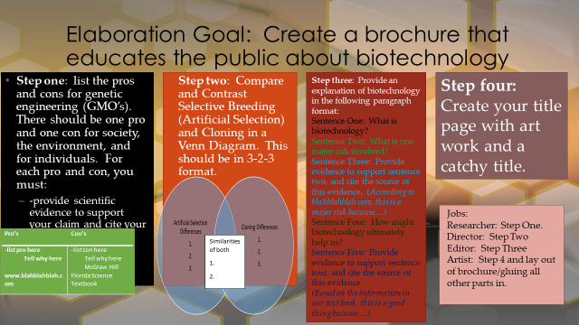

4-Excellent 3-Good 2-Needs Improvement 1-Not There
__ Pros and Cons given for genetic engineering-1 for society, 1 for individuals, and 1 for the environment.
__ It is obvious you understand the impact of biotechnology.
__ Relevant evidence is given to support claims.
__ It is clear you know the difference between cloning and selective breeding.
__ You have relevant illustrations.

___ Totalx5= ____/

