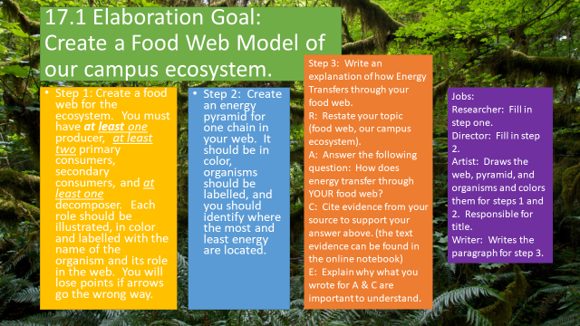

4-Excellent 3-Good 2-Needs Improvement 1-Not Present
__ The food web contains one producer, one decomposer, two primary consumers, and two secondary consumer. The web is labelled with the names and the roles of the organisms.
__ The energy pyramid takes one food chain from your web, and it is labelled to show where the most and least energy are.
__ There is a RACE paragraph explaining how energy transfers through an ecosystem, with text evidence cited.
__ The poster is illustrated and in color.
__ All information is accurate of the ecosystem.

