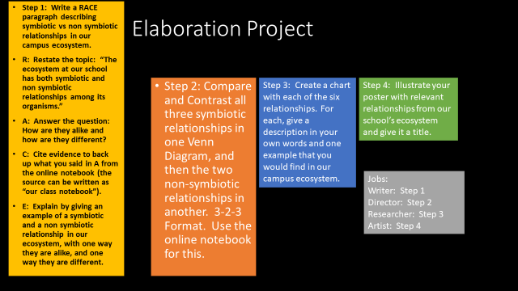
4-Excellent 3-Good 2-Needs Improvement 1-Not Present
__ There is a RACE paragraph describing one relationship that you have with an organism of another species.
__ There is a Venn diagram comparing and contrasting all three symbiotic relationships, which is labelled and in 3-2-1-3 format.
__ There is a Venn diagram comparing and contrasting both non-symbiotic relationships, which is labelled and in 3-2-3 format.
__ There is a chart with all six relationships that includes a description and an example from your ecosystem.
__ All information is accurate of the ecosystem, and the poster is in color and illustrated.

