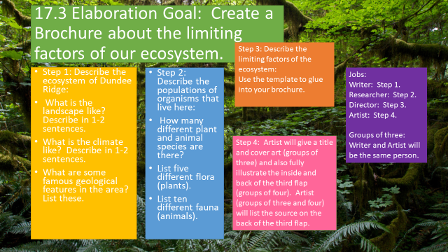
4-Excellent 3-Good 2-Needs Improvement 1-Not Present
__ All five sections are illustrated and in color, and the product is a tri-fold brochure.
__ The ecosystem is accurately portrayed.
__ Communities and populations are described accurately.
__ All limiting factors are described.
__ A source is given.

Total: ___ x5= ____/_____

