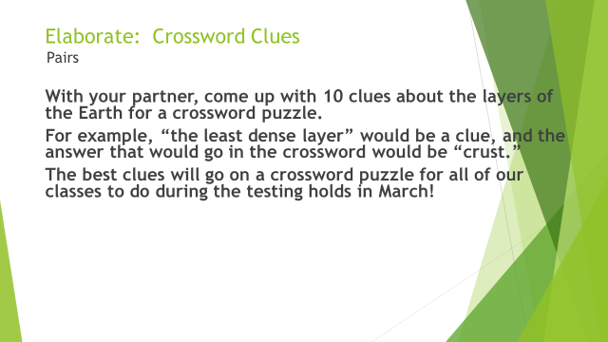

Layers of the Earth Crossword Clues (1-Doesn’t exist; 2-Somewhat exists; 3-It’s there; 4-It’s perfect)
__ There are 10 clues.
__ There are 10 answers.
__ All clues accurately describe something about the layers of the Earth.
__ All answers are correct.
__ You have not used the same answer twice.

