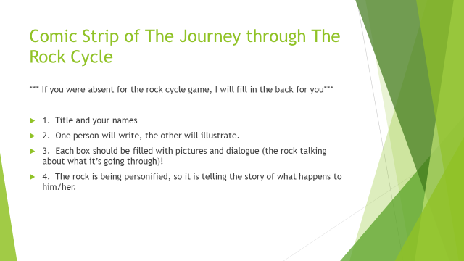
SEE ME FOR THE WORKSHEET; there is no exemplar for this project.
4-Excellent 3-Good 2-Needs Improvement 1-Unsatisfactory
___ The journey through the rock cycle is documented.
___ Evidence of this journey is presented in the comic strip.
___ There is dialogue that explains the rock cycle.
___ Each cell is filled with color and relevant art.
___ The comic strip is creative and the team put in effort into making it.

