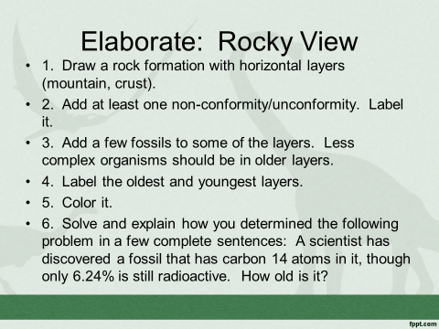
4-Excellent 3-Good 2-Needs Improvement 1-Not Present
__ Rock formation is drawn with horizontal layers. The drawing is in color.
__ An unconformity is present and labeled correctly.
__ There are some fossils in the layers, with obvious less complex in the bottom layers and more complex in the top.
__ The oldest and youngest layers are identified.
__ The radioactive dating problem is solved correctly.

