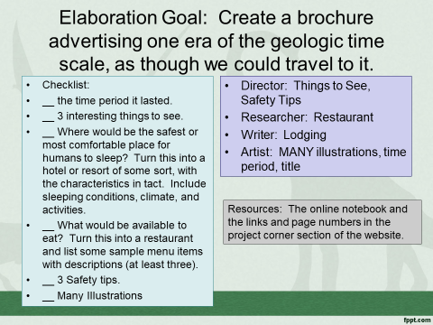
4-Excellent 3-Good 2-Needs Improvement 1-Not Present
__ There are three interesting things to see and three safety tips.
__ The time period is given.
__ A creative solution has been given to a place to sleep, turning it into a resort or lodge.
__ A creative solution has been given for the available food, turning it into a restaurant.
__ There are many colorful and relevant illustrations.

