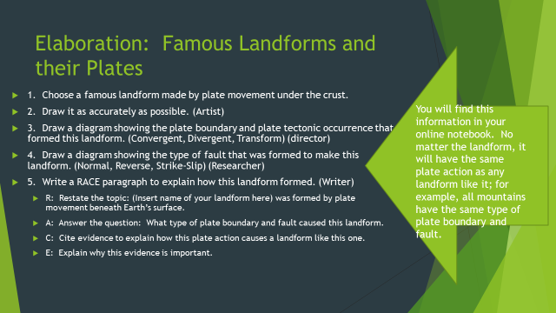
THERE IS NO EXEMPLAR FOR THIS. IF YOU ARE MAKING THIS UP BECAUSE YOU WERE OUT, GO WITH MOUNT EVEREST AS YOUR LANDFORM. YOUR SOURCE SHOULD BE THE ONLINE NOTEBOOK.
4-excellent 3-good 2-needs improvement 1-unsatisfactory
__ Landform has been drawn accurately to the best of the team’s effort.
__ Plate boundary/plate tectonic occurrence has been diagrammed accurately.
__ Fault activity has been diagrammed accurately.
__ Paragraph follows RACE format and accurately explains the formation of this landform.
__ Group worked well together and did not waste time

TOTAL: ____x5=____/____

