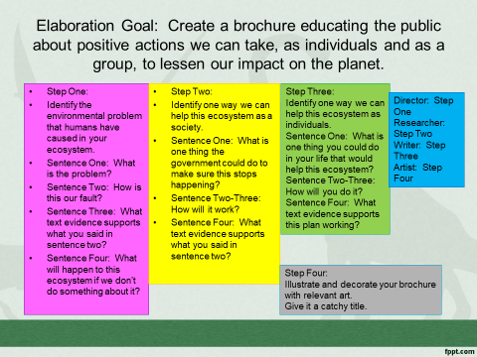
4-Excellent 3-Good 2-Needs Improvement 1-Not There
__ The problem is described and our role identified.
__ A solution that society can take has been identified and described.
__ A solution that individuals can take has been identified and described.
__ Text evidence has been given for each paragraph.
__ There are many relevant illustrations and artistic decorations.

