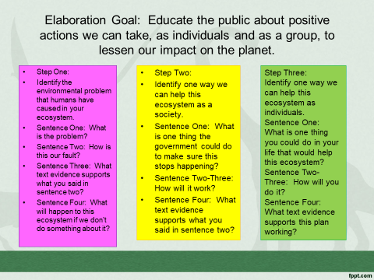
4-Exceeds Expectation 3-Meets Expectation 2-Approaching Expectation 1-Not Approaching
___ You can locate information on a scientific finding in a text.
___ You can locate evidence to support a scientific finding.
___ You can explain how evidence supports a scientific finding.
___ You are able to explain a scientific finding.
___ Proper citation is used for all text evidence.

Total: ___ x5= ____/_____

