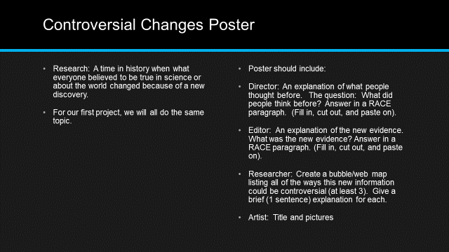

4- Excellent 3-Good 2-Needs Improvement 1-Not Present
___All information is researched and accurate to the best of our ability.
___The old science was explained in a RACE paragraph.
___The new evidence was explained in a RACE paragraph.
___An explanation of how this could be controversial was presented in a web format, with at least 3 controversies and a reason.
___The pictures and lay out relate to the content and show our best effort.
___Total x5=____/

