Welcome to Ms. Ramos’ Virtual 7th Grade Science Class!
Hello everyone! I know this is a strange time in all of our lives, and school might be the last thing on your mind. I want to make this process as simple as possible for all of us, so I’m willing to help you in any way I can. While the district has not officially changed the go-back date for NORMAL school from 4/15 (I’m saying this to you as of 12:15pm, Monday, March 30th…this could change at any time), it is very possible that we will be doing the virtual learning from home instead for longer, especially since the President’s announcement yesterday of extending shut-downs to at least April 30th. You, or maybe your parents, know that this has been changing daily. As of right now, I have lessons planned for virtual class through 4/17. I will share those plans with you here, so you know what to look forward to.
I want to be as flexible with you as possible, as I know working from home is going to be very different for you. If something doesn’t work for you, let me know, and I will work with you in any way I can to make this experience work for you. I am not planning any “live” classes, so you will be able to log in on your time any time before 3pm each school day. We will not begin until this Thursday, April 2nd, so logging in and working on anything I may have available before that is up to you. Also, you should be aware that next Friday, April 10th, is Good Friday and is a school holiday. You will not be expected to log in to our class that day.
First things First: We will be using Microsoft Teams as our main classroom. You will be able to continue using our class website for the notebook and any other resources you may need from there, as well. We will continue to do our quizzes on zzi.sh. At the end of this page, there are graphics to show you how to get to Teams.
Assignments: Each week, you will have two assignments: a small project and a quiz (that you can do exactly the same way we always have). You will find these posted in Microsoft Teams under your class. I will assign the projects on Mondays, and they will be due by 11:59pm on Saturday.
Attendance: I will take attendance each school day by having you log in to Teams and do a bellwork question. Just like in class, you will read the question and decide which answer you think is correct. You will then reply to the question with your answer and a QUICK reason why (the letter only, and then type out your reason). These questions will be available daily by 8:30 am, and be due by 3pm (so that I can get attendance submitted in the system by 4pm). There will only be one question each day. At the end of the day, after everyone has answered, I will post a video explaining the answer to the question. You can reply to the video, or contact me personally for any follow up questions, if you need extra help (this part is not required, but you should at least watch the videos to help you with the projects and quizzes). I will not only use this for attendance, but I will also use it as part of your weekly grade. If you do not do the bellwork question daily, you will be marked absent. Remember, it doesn’t matter if you’re wrong here, it matters that you show up and try.
Office Hours: 2pm-3pm Monday-Friday. Office Hours mean that I will be available right away to talk to you about anything you need help with. My phone number is 863-604-4553. You can text me, but if you want to talk on the phone, you will need to text me first and tell me to call you, as I don’t usually answer calls for people I don’t know. You can also contact me by email, remind, and the chat feature on Teams, which can be used for a video chat, if you prefer. While 2-3 are my official office hours, that does not mean I’m not available to help you almost any other time (unless I’m sleeping); however, outside of office hours, my response may not be immediate.
Schedule Through 4/18:
Day | Task
Thursday, 4/2 | Answer Bellwork Question/Orientation Quiz Opens
Friday, 4/3 | Answer Bellwork Question
Saturday, 4/4 | Orientation Quiz due by 11:59 pm
Monday, 4/6 | Answer Bellwork Question/6.2 Project and Quiz Open
Tuesday 4/7 | Answer Bellwork Question
Wednesday 4/8 | Answer Bellwork Question
Thursday 4/9 | Answer Bellwork Question
Saturday 4/11 | 6.2 Project and Quiz due by 11:59pm
Monday 4/13 | Answer Bellwork Question/6.5 Project and Quiz Open
Tuesday 4/14 | Answer Bellwork Question
Wednesday 4/15 | Answer Bellwork Question
Thursday 4/16 | Answer Bellwork Question
Friday 4/17 | Answer Bellwork Question
Saturday 4/18 | 6.5 Project and Quiz due by 11:59pm

See next two pages of Microsoft Teams Log In Info.

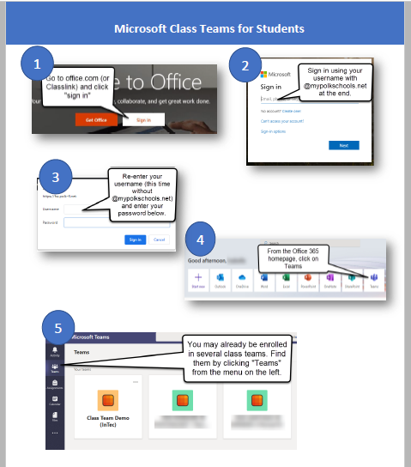
Logging in to Microsoft Teams using a Computer

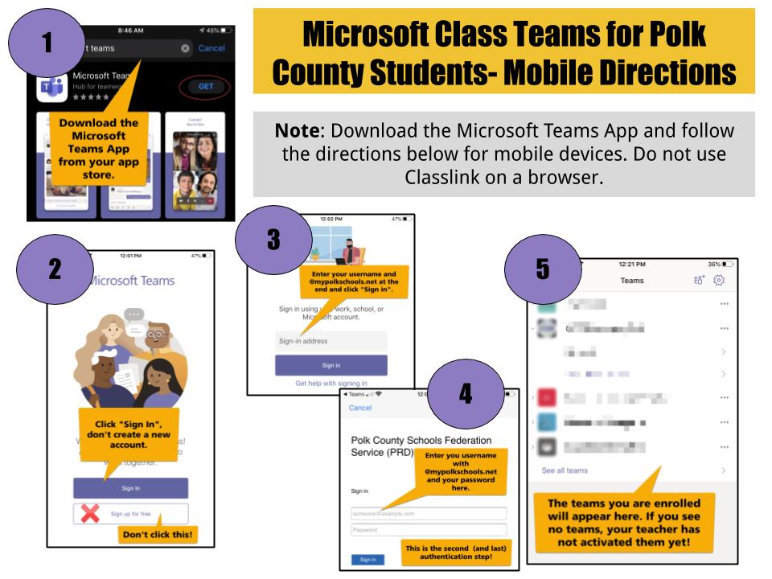Logging in to Microsoft Team on a Phone or Tablet ^^

